Project Proposal – Project 3 – Group 4

Group 4 Members: Thanh Vinh Giang, Hao Nguyen, Uthpalie Thilakaratna, Tammy Powell

GitHub Link: https://github.com/alvin-giang/Movie_Database-Data-Engineering.git

TOPIC /RATIONAL : (Data Engineering)

**Extracting movie data from 2019 to 2024 for the purpose of cleaning and creating a database.**

URL: <https://developer.themoviedb.org/reference/discover-movie>

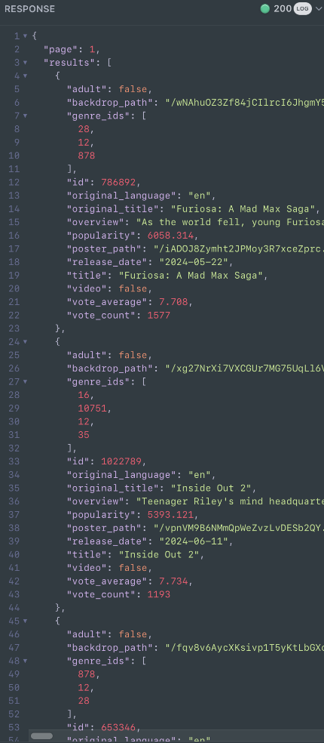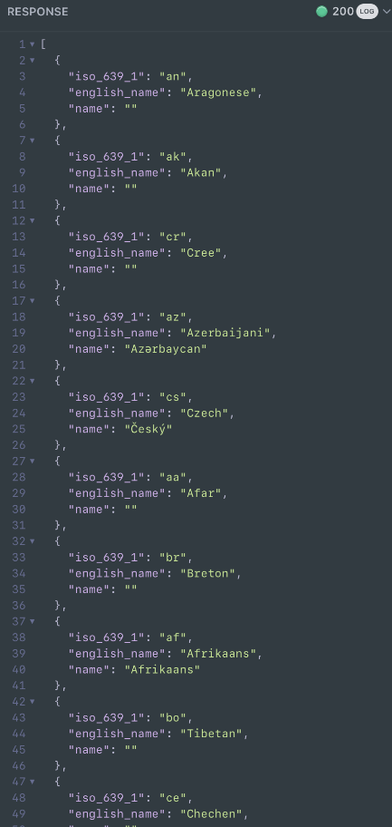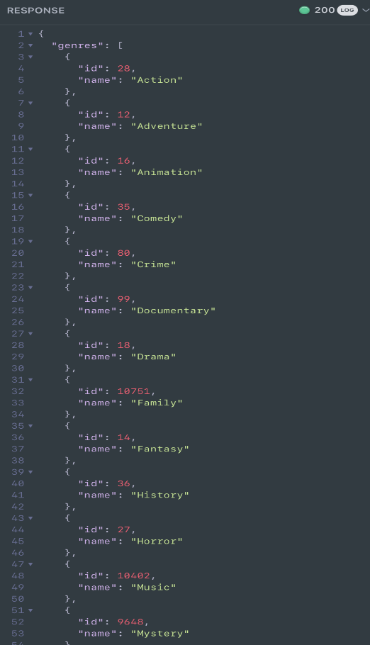

Additonal Library: PyPI > ERAlchemy > Simple entity relation (ER) diagrams generation

Extracting/Transform/Load

Source

SQL Database

ERD

Flask API

Analyse